Use physics to describe the operation of technological devices, and to solve problems

Introduction: Forces and Motion – Year 11 information in 1 easy lesson (plus year 12 work!)

Speed & Velocity
- The rate at which a body moves from one location to another is usually described as either speed (s) or velocity (v)

Average velocity (ms⁻¹) = Distance covered (m)
Time taken (s)

d

v t

- if it took 4 hours to travel from Dunedin to Christchurch which is 360km, what is the average speed?
- Egs:
- What is the speed of a car in kmh⁻¹ if it covers 15km in 30 minutes?
- Find the speed of a runner in ms⁻¹ if she covers 1000m in 7 minutes.

Converting Units
kmh⁻¹ is converted to ms⁻¹ by…… x 1000 (m in km) ÷ 3600 (s in hr)

ms⁻¹ is converted to kmh⁻¹ by ….. x 3600 ÷1000

Egs:
- A cricket ball is bowled at 134km per hour.
- Convert 134 kmh⁻¹ to ms⁻¹ (37.22)
- If the batsman is 18 m from the bowler when the ball is released, how long has he to prepare this stroke? (about 0.5 s)
- Stephen fancied himself as a tennis player. He asked Peter to time his serves from the serve line to the netting fence (30m)
- Find the speed of the serve in metres per second if the measured time was 1.2s. (25)
- Convert this speed to kmh⁻¹

Distance-Time Graphs

d stop

constant speed

Acceleration
- An object changing its speed is accelerating – positively or negatively (decelerating)

Acceleration (ms⁻²) = final velocity – initial velocity (Δv)
Time taken (s)

v
a t

- Eg: Calculate acceleration of a trolley which changes from 2ms⁻¹ to 5ms⁻¹ in 2 seconds.

Velocity-Time graphs

To find acceleration , calculate run over rise ie v÷ t using the gradient of the graph
v constant speed

acc^{n}

t

Activity:
Optional Year 11 Pathfinder: p38-9 no’s 3, 4, 5, 6, 7, 10,11

Vectors and Scalars
- A scalar is a physical quantity that has size (magnitude) but no direction. Egs include distance, speed and temperature
- A vector is a physical quantity that has both size and direction. Egs include displacement, velocity and force
- A vector can be represented by an arrow. The length represents the magnitude and the arrow represents the direction.

- Vectors can be added graphically by placing the tail of the second vector on the head of the first. The vector drawn from the tail of the first vector to the head of the second vector is the resultant. It is identified by a double arrow.
Eg Tom walks 6m in an easterly direction followed by 8m in a northerly direction. Find:
- the total distance Tom has travelled
- the shortest distance from the starting point.
Solution:
- The total distance is 6+8 = 14m
- The shortest distance is calculated using a vector diagram and pythagoras’ theorem which states that for a right angled triangle, the hypotenuse squared equals the sum of the squares of the other two sides. So: √6² + 8²
= √ 36 + 64
= √100
= 10m

Let’s Get Moving- Checking Motion understanding!

- Complete the table.
Name | Symbol(s) | Metric unit | Some other units | comment
Time |  | s | minute, ______ | How ________ an even takes to occur
 | d | m | cm, ____ | How _______ something has travelled
Speed | v | ______ or _____ | mms⁻¹, ______ | Distance covered during one unit of _______
 | v | ms⁻¹ | ______, kmh⁻¹ | Speed in a particular ____________
Acceleration |  | ms⁻² | Kmh⁻¹s⁻¹, ______ | Rate of change of ___________

- Use the formula triangles to complete the equations.

Δd

v Δt

Δv

a Δt
v = a =

Δd= Δv=

Δt = Δt =

- Complete the table
Distance Travelled | Time taken | Speed
100m | 20s
 | 5s | 12cms⁻¹
2.5km |  | 125ms⁻¹
1500km |  | 100kmh⁻¹
 | 15min | 80kmh⁻¹
186km | 3h

Initial speed | Final speed | Change in speed | Time taken | Acceleration
5ms⁻¹ | 17 ms⁻¹ |  | 4s
0kmh⁻¹ | 72kmh⁻¹ |  | 24s
 | 15 ms⁻¹ | -50 ms⁻¹ | 10s
 | 35kmh⁻¹ | 15kmh⁻¹ |  | 5kmh⁻¹s⁻¹
35 ms⁻¹ |  | 55 ms⁻¹ | 11s
 | 180kmh⁻¹ |  | 4s | -15kmh⁻¹s⁻¹

- What does a negative acceleration tell you?

- Convert these measurements to the new units. Show your working.

a) 1km = m
b) 1675m = km
c) 1h = s
d) 720s = h
e) 72kmh⁻¹ = ms⁻¹
f) 5 ms⁻¹ = kmh⁻¹

Forces – Checking what you know
- Forces push, pull, tug, heave, squeeze, stretch, twist or press.
- Forces change: the shape of an object
the movement of an object
the speed of an object
- Some forces act by contact which needs to touch an object to produce an effect, eg pushing by hand, ocean waves crashing on rocks, tiny forces holding a soap film together eg thrust, support, friction (drag)
- Some forces do not need contact, and can act at a distance. These are non contact or field forces eg magnetic, gravitational and electrostatic

Direction and Strength of Forces
- Forces can act upwards, downwards, sideways, or any direction at all.
- Arrows are used to show direction of forces
- Strength of force is shown by the thickness or length of an arrow.
Gravity (weight)


Thrust
Friction (air resistance)

Support (lift)

Measuring Forces
- Meters that measure forces usually have springs in them. The bigger the force the more the spring is squashed or stretched.
- Spring balance or forcemeter or newtonmeter are often used in schools.
- A spring is stretched by the pulling force and squashed by the pushing force.
- The amount of force has a unit called a newton (N)
- Notice that 1kg = 10N. What would 2kg be? 0.5kg? 100kg?

Balanced and Unbalanced Forces
- The forces acting on an object determine how that object will move. If we push on some object and the object doesn’t move, then the force we exert must be balanced by another force.
- An unbalanced force will produce acceleration

Newton’s First Law of Motion
If the forces acting on an object are balanced, then the object will either stay still or keep moving at the same speed in the same direction. Thus a force is needed to make something
Force 1 = Force 2
Balanced Forces
No movement
speed up or slow down or change direction.
Force 1
Force 2

Eg. In a car crash, a large force acts on the car and quickly stops the car. However, the driver will keep on moving with the same speed in the same direction until a force slows him or her down. The force is hopefully provided by a seatbelt or airbag. Without either, the driver may continue moving right through the windscreen and out of the car.

Newton’s Second Law of Motion
If there are unbalanced forces acting upon an object, then the object will accelerate in the direction that the net force acts. The size of the acceleration depends upon the mass of the object and size of the force. This is illustrated by the relationship F=m.a
Force 2
Force 1
Force 1 > Force 2
Unbalanced Forces
Movt to Right

In sport, acceleration can be improved by better force from muscular contraction or reducing the weight of the object to be moved. Eg for javelin, shotput etc you can improve strength and for running you can reduce weight.

Laboratory: Tug of War

Acceleration due to Gravity
- A free falling object has an acceleration of 9.8ms⁻² (more commonly rounded to 10ms⁻²). This means that each second its speed will increase by 10ms⁻² until it reaches terminal velocity

Laboratory: Determining acceleration due to gravity

Tug-O-War

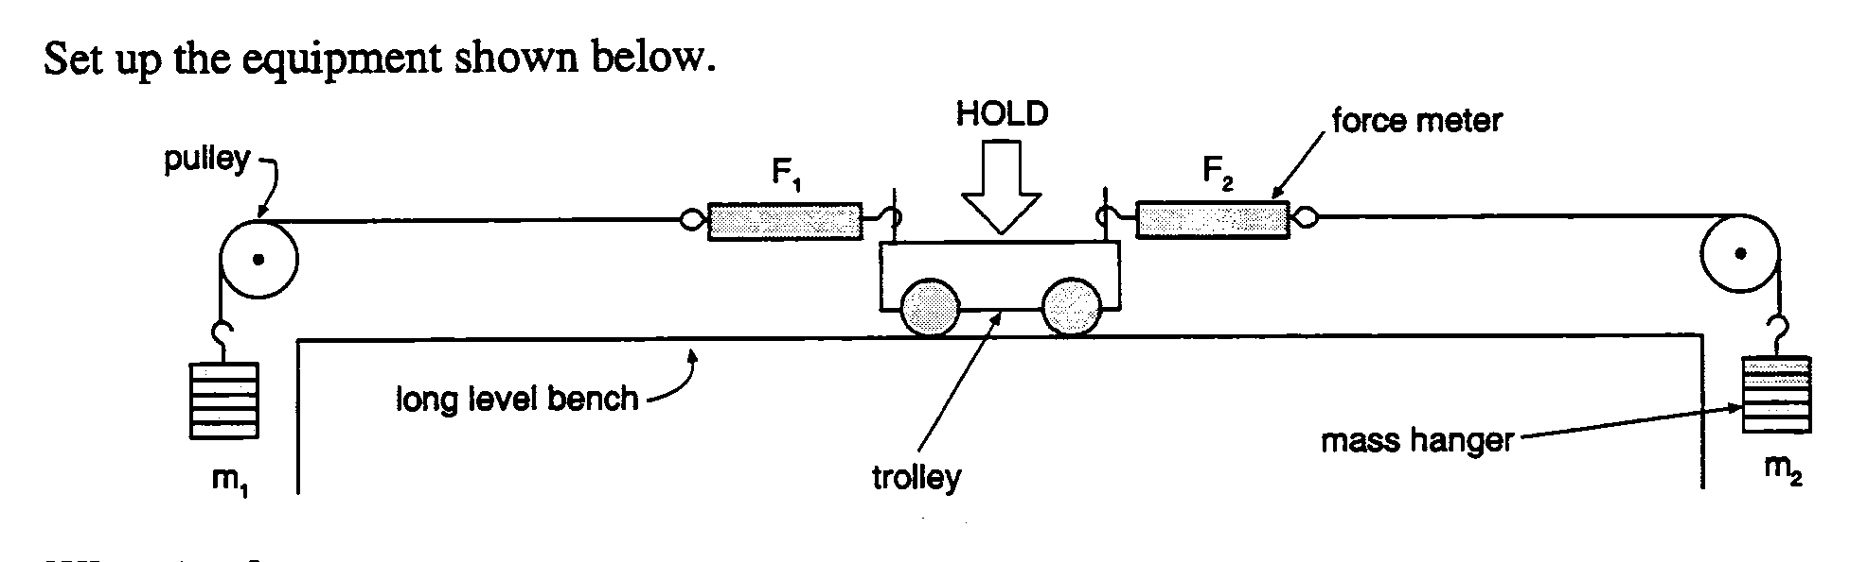

What to do:
- Have one person hold the trolley still in the middle of the bench
- By varying the sizes of m₁ and m₂ set up each force arrangement shown in the table below
- When each arrangement is ready, record F₁ and F₂ then let the trolley go and observe the motion.
NB: Catch the trolley before it crashes or else!

Results:

Arrangement | F₁(N) | F₂ (N) | Net force (N) | Observation with respect to acceleration
F₁ >>>>>F₂
F₁ > F₂
F₁ = F₂
F₁ < F₂
F₁ <<<< F₂

Conclusion:
Write a statement which summarises your findings.

Determining the Acceleration of Gravity

Materials: strong thread, large metal washers, retort stand, metre ruler, stopwatch

Principles and Method:
- When a body accelerates, its velocity changes over time. For eg; if you drop a ball from the top of a tree, gravity pulls on the ball and causes it to move faster and faster toward the ground. If a body has an acceleration of 9.8ms⁻², this means that after one second, the body has a velocity of 9.8ms^{-1-,} after 2 seconds, a velocity of 19.6ms⁻¹ and so on.
- Gravity is a force that causes the pendulum to accelerate and swing back and forth. We will use a pendulum to find the magnitude of the acceleration of gravity because the pendulum executes simple harmonic motion.
T= 2Π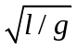
T= the period of the pendulum, l is the length of the pendulum, and g is the acceleration of gravity. There is no mass in the formula indicating the period (time) is independent of mass.

- Pull the pendulum back 10-15º and release. Measure the time required for the pendulum to swing 10 times, and divide by 10 to find the average T. Substitute this value and the measured length of the pendulum (from retort stand to washer) into the following equation and solve for g:
g= 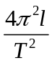

- Record your results in the table below. Repeat with 3 different lengths of pendulum, and calculate an average value of g. The accepted value for the acceleration is 9.8ms⁻². What experimental errors might you have made?
- Calculate the relative error of your values of g using the following formula:
Relative error= (observed – accepted) * 100% = ( your g – 9.8) * 100% =
Accepted 9.8

Length of pendulum (m) | TRIAL- period T (s) |  |  | Average calculated acceleration of gravity g (ms⁻²) | Average Relative error  %
Length of pendulum (m) | 1 | 2 | 3 | Average calculated acceleration of gravity g (ms⁻²) | Average Relative error  %

Mass and Weight
- Mass is the amount of matter in an object, measured in kg. The mass of an objects is the same regardless of where it is located in the universe.
- The weight of an object is the force of gravity that acts on the object. The weight of an object depends on where it is located in the universe.
- Weight is measured in newtons (N) because it is a force.
- Weight can be calculated from F_{w} = m.g where g is the acceleration due to gravity and on earth, is accepted as 10Nkg⁻¹.
- The weight of an object on the moon is 1/6 that on Earth because the gravitational field strength is less.

Worksheets
- Some ‘quick’ problems
- ESA book (y11)
- 12 physics pathfinder exercises.

Equilibrium
- When the resultant force on an object is zero, the object is in equilibrium.
- In this case, the object is either not moving (static equilibrium) or it is moving in a straight line at constant speed (dynamic equilibrium).
Some ‘Quick’ Problems

- The diagram shows the forces being applied to a 160kg bicycle and rider.
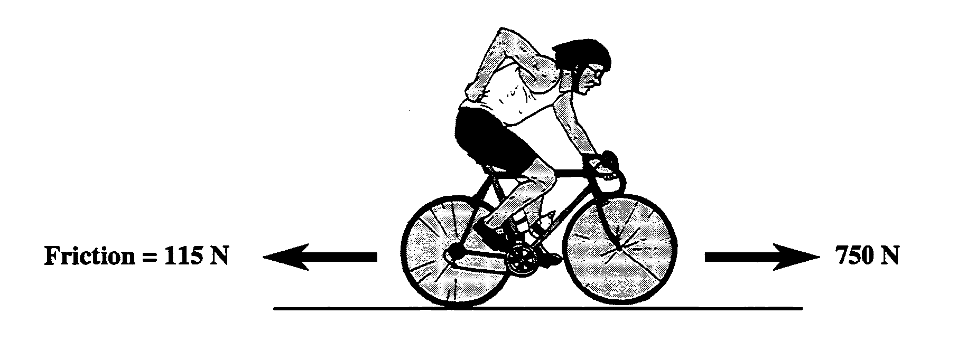
- what is the direction and size of the nett force acting on the bike and rider?

- Calculate the acceleration of the bike and rider. Give the correct unit with your answer.

- A motorbike with its rider has an acceleration of 10ms⁻².

The nett force exerted by the engine is 5800N.
Calculate the combined mass of bike and the rider.

- How would the acceleration of a dragster be affected if the
following changes were applied?
  - the mass of the dragster remains constant but……
  - the engine is tuned up to give twice the force

  - the engine is de-tuned to give half the force

  - the engine force remains constant but…..
- the mass of the dragster is doubled

- the mass of the dragster is halved.

Torque -Optional reading from pp167-9 for Torque.
- Forces are often used to rotate or turn objects – this turning effect is called a torque or moment.
- The turning of a door handle, using a spanner to tighten a nut and the force applied to the pedal of a bicycle are examples of torques.
- The torque is always stated relative to a point called the pivot.
- To describe a torque, the size of the force and the perpendicular distance between the line of action of the force and the pivot must be known.
- Torque is calculated as:
T = F. d⊥

Where F = Force and
d⊥ = perpendicular distance between line of action at force and pivot
- The SI unit for torque is the Newton-metre, Nm. The direction of the torque is usually stated as being clockwise or anticlockwise

Balanced Ruler
- A suspended ruler was balanced by moving a mass-stack to a position where the ruler no longer turns.
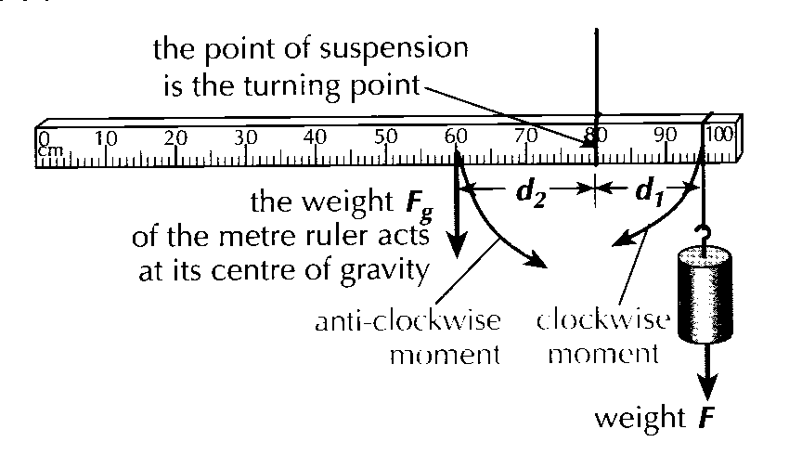
- The weight F of the mass-stack produces a clockwise torque T_{c} = Fd₁ where d₁ is the distance of the point of suspension of the mass stack from the pivot.
- The weight F_{g} of the ruler acts through its centre of gravity.
- The weight F_{g} of the ruler produces an anit-clockwise torque T_{A} = F_{g}d₂ where d₂ is the distance of the centre of gravity of the ruler from the pivot.
- The balanced suspended ruler is said to be in rotational equilibrium as it obeys the principle of turning moments

Principle of Turning Moments
For an object in rotational equilibrium, the sum of the clockwise torques = the sum of the anticlockwise torques. Ɛ T_{A} = Ɛ T_{C} ie F_{g}d₂ = F d₁

Example:
A metre rule of negligible mass is pivoted at the 30cm mark. A mass weighing 20N is suspended from the 70cm mark. What weight must be suspended from the 20cm mark to balance the metre rule?
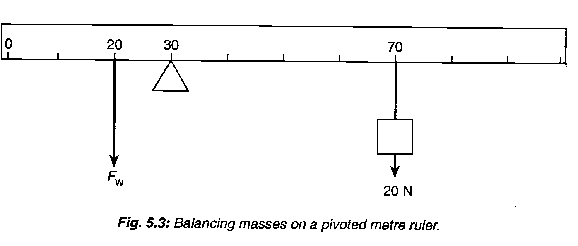
Ɛ T_{C} = 20 * (0.7-0.3)
Ɛ T_{C} = 20 * 0.4
= 8Nm

Ɛ T_{A} = 0.1F_{w}
At equilibrium: 0.1F_{w} = 8Nm ∴ F_{w} = 8 ÷ 0.1 = 80N

Force and Torque Equilibria
- Consider the diagram below which represents the forces acting on a bridge as a car crosses it.
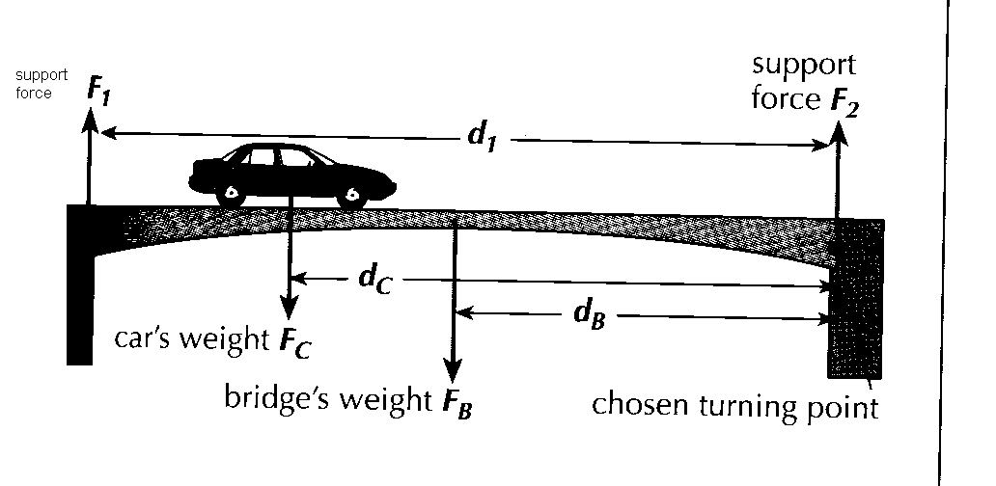
- F₁ and F₂ are the two support forces
- F_{c} is the weight of the car
- F_{B} is the weight of the bridge which acts at the centre of the bridge (its centre of gravity)
Force equilibrium and Newton’s First law of motion
- The forces acting on an object in a particular direction must be in equilibrium (balanced) if there is not movement in that direction.
- Newton’s first law of motion can be applied to the bridge in the vertical direction:
Sum of the upward forces = sum of the downward forces  F₁ + F₂ = F_{c} + F_{B}
Torque equilibrium and the Principle of Turning Moments
- The torques acting on an object are in equilibrium if there is no rotational movement.
- The above principle can be applied to the bridge for any chosen turning point. The pivot is taken to be the top of right bridge support.
- The support Force F₁ produces a clockwise moment equal to F₁d₁ where d₁ = distance of F₁ from the pivot.
- The support force F₂ produces a zero moment as it acts through the pivot
- The weight of the car F_{c} produces an anti-clockwise moment = F_{c}d_{c} where d_{c} = distance of F_{c} from pivot.
- The weight of the bridge F_{B} produces an anti-clockwise moment = F_{B}d_{B} where d_{B} = distance of F_{B} from pivot.
- As there is no rotational movement of the bridge:

Sum of anti-clockwise torques = sum of clockwise torques
F_{c}d_{c} + F_{B}d_{B} = F₁d₁

TORQUE

AIM: To find the mass of a ruler using torques in equilibrium.

EQUIPMENT: metre ruler, clamp stand, string, mass stack and masses, plasticine, scales

METHOD:
- Use some string to hang the ruler, at its centre (the 50 cm mark), from the clamp stand. Ensure that it hangs horizontally. You may add a small amount of plasticine at the end of the ruler to balance it. Remember to take account of any plasticine at the end of the experiment. Now you are ready to start.
- Hang the ruler from its 30cm mark. (You will need to support the ruler initially with your hand because it will not balance)
- Using the mass stack and masses (total mass 200g) balance the ruler so that it hangs horizontally. The diagram below may help you.
Note : The weight of the ruler acts at the centre of the ruler.

0 30 50 cm 100
Clamp Stand
Masses & hanger
metre ruler
F_{W}
Weight of ruler

RESULTS:
- Record the distance from the ruler suspension point to the mass hanger. (in m)
- Record the distance from the ruler suspension point to the centre of the ruler.
- Record the mass and weight of the mass hanger and masses.
- Use your measurements to calculate the weight and mass of the ruler. (with plasticine) Remember if your ruler is properly balanced the anticlockwise torque will equal the clockwise torque.
- Use the scales to find the mass of the ruler. (with plasticine)

CONCLUSION:
Compare your result for the mass of the ruler using torques in equilibrium with the mass found on the scales. Comment on the validity of using torques to find a mass.

EXTENSION:
Write a plan for an experiment using torques in equilibrium to find the mass of an apple. (Equipment available – 50g masses and hanger, ruler, plasticine, string, apple, clamp stand)

Levers
- A lever is a simple machine that can be used to reduce the effort required to overcome a load force or to make a job easier to achieve.
- There are 3 types of levers, grouped according to where the turning point (fulcrum) is.

First order Levers
- The turning point is between the effort and the load.
- A small effort force can be used to overcome a large load force.
- Egs: screwdriver, claw hammer (back of hammer to pull nail out), pair of pliers

Fulcrum
Load effort

Second order Levers
- The load acts between the turning point and the effort.
- A small effort can be used to overcome a large load force
- Egs: nutcracker, bottle opener, wheelbarrow
effort

fulcrum load

Third order Levers
- The effort acts between the turning point and the load.
- The effort is always greater than the load but it remains a convenient lever.
- Egs: food tongs, human forearm
Effort

Fulcrum load

Exercises
From ESA Y11- Torque and equilibrium
Y12 Physics – torque and equilibrium

Energy
- Energy is a concept that is used to describe and explain changes in the physical world.
- Defined as the ‘ability to do work’. Its SI unit is the joule (J)
- Energy cannot be created nor destroyed, but is always conserved.
- Energy can be transformed from one form to another.
- A transducer is an instrument that transforms energy. Eg an electric heater changes electrical energy to heat energy.

Complete the following table:

Type of Energy | Definition | Situations where energy may be found
 | Energy of the electromagnetic spectrum eg heat,light | Television, radiant heater
Nuclear energy | Energy stored in the of an atom | Nuclear reactor
 | Energy of a moving object
Gravitational potential energy | Energy stored in an object because of its position in the Earth’s gravitational field
 | Energy stored in a compressed or stretched spring
 | Energy stored in food, fuel or chemicals
Sound energy | Energy emitted by a v………… force

- Kinetic as well as elastic and gravitational potential energy are all classified as forms of mechanical energy.

Work and Energy
- When mechanical energy is transferred from one object to another, the amount of energy transferred is considered the work done.
- Work (W) is therefore measured in joules
- Work is done when a force (F) moves an object through a distance (d) in the direction that the force acts.

W = F. d

- 1J is equivalent to 1Nm – the amount of work done when a force of 1N moves an object a distance of 1m.
- Eg: A horizontal force of 5N is used to push a book 1.5m across a table. The work done is:
W=F.d 5 * 1.5 = 7.5J
- Eg: at the start of a race, a rower pulls her oars backwards a distance of 0.8m during a stroke, exerting a constant force of 250N, W = F.d 250N * 0.8m = 200J
There has been an energy transfer to 200J of potential energy from her muscles to 200J of kinetic energy.

Efficiency:
In addition to the 200J of ‘useful’ energy transfer, some energy will be ‘wasted’ in heating – rowing makes you hot!- so rather more than 200J will have been transferred from her muscles. The efficiency of any energy transfer process is defined as:

Efficiency = energy usefully transferred
Total energy transferred

Efficiency is often expressed as a %. For eg, if the rower’s muscles are 20% efficient, then 20% of the energy transferred does work on the oars, while the remaining 80% is wasted in making her hot!

Activity:
An uplifting experience

Looking at Work

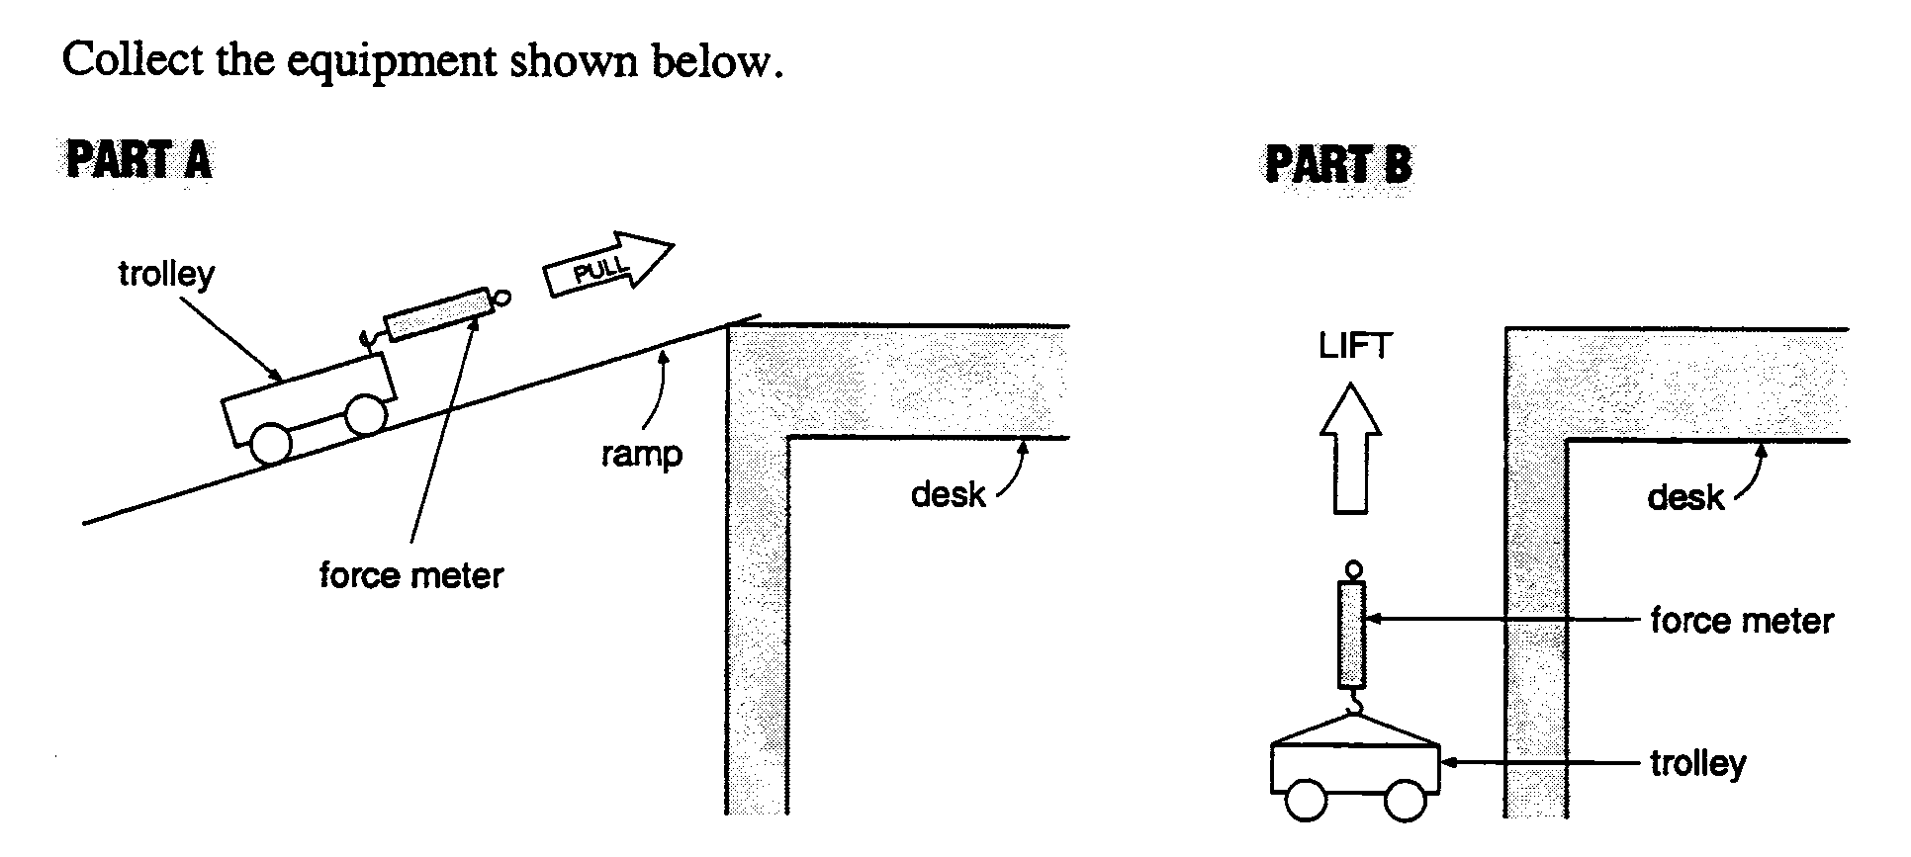

What to do:

1. PART A:
a) Pull the trolley at a very slow steady speed up the ramp from the floor level to the desk
top level.
b) While pulling, record F₁ N
c) Measure the distance along the ramp. d₁ m

2. PART B:
a) Lift the trolley at a very slow steady speed from the floor level up to desk level.
b) While lifting, record F₂ N
c) Measure the height of the lift. d₂ m

3 a) calculate the work done in part A:

b) calculate the work done in part B:

- Compare the results in 3(a) and 3(b). Comment fully on your findings (eg disadvantages, advantages of using a slope.)

Gravitational Potential Energy
- When an object of mass m is lifted a height h, work has been done because a force has been applied to the object and moved it in the direction of the force.
- If work has been done, mechanical energy has been transferred to the object.
- The type of mechanical energy the object being lifted gains is gravitational potential energy. E_{p}
- For a change in quantity, the symbol Δ is used so ΔE_{p} means a change in potential energy
- When an object is lifted, its gain in E_{p} is equal to the work done by the lifting force
- The force F needed to lift an object at a constant speed is equal and opposite to the object’s weight F_{w}.
- Putting these ideas together gives:
Gain in gravitational potential energy
= work done  ΔE_{p} = W
= F.d  ΔE_{p} = F. d
= F_{w} . height lifted  ΔE_{p} = F.g.h
= mass. g. height  ΔE_{p} = m.g.h

NOTE: mass in kg, height in m, g = 9.8ms⁻²
- Eg: Tahi (mass 75kg) stands on a 2m high diving board. What is his gravitational potential energy?
Ans: ΔE_{p} = m.g.h 75 * 9.8 * 2 = 1470J

Kinetic Energy
- When we do work in accelerating a body from rest, the body gains mechanical energy called kinetic energy (E_{k}) – energy due to motion.
- It can be shown that : E_{k} = ½ mv²
- This gain in energy should be equal to the work done by the force acting on it.
Ie E_{k} = F.d

Eg. A car of mass 1500kg accelerates from rest to a speed of 70kmh⁻¹ (20ms⁻¹).
How much work is done in getting the car to this speed?
Work done = Energy given
= ½ mv²
= 0.5 * 1500 * 400
= 300 000J
= 300 kJ

However, not all the work done by the motor turns into kinetic energy. Much of it will be used to overcome friction. The motor will also become hot: some of the energy produced will be the form of heat energy and because we can hear the car, we know some of the energy produced is in the form of sound energy.
Examples:

1. Calculate the kinetic energy of a 3kg bullet moving at 400ms⁻¹ 600 J

2. Two cars have equal mass. Car P is travelling at 50kmh⁻¹ and car Q is travelling at
100kmh⁻¹. The kinetic energy of P and Q is? What mathematical relationship do you
notice by doubling the speed?

3. Acapulco, Mexico is the home of high diving championships, where divers jump from a
ravine 35m above the sea.

  - Calculate the loss in gravitational potential energy, and hence the gain in kinetic energy, of a diver of mass 65kg,a nd so calculate the speed on hitting the sea.

  - Explain whether a more massive diver would hit the sea at the same speed. (Assume the diver falls freely, ie gravity is the only force acting, and use g = 9.8Nkg⁻¹ = 9.8ms⁻²)

Worksheet: p48 of y12 physics

Back and forth

Set up the equipment shown opposite:

What to do:
Support the mass on the back of your hand as steadily as possible.

Switch on the time and move your hand quickly downwards so that the mass falls entirely under the influence of gravity

    - Use your ticker tape to find the maximum speed in ms⁻¹
  - measure the length (x) of the biggest interval in m x= ________ m

  - Calculate v = x ÷ 0.02 = ms⁻¹

    - Use your tape to find the drop height (h) in m:
      - mark the first dot and mark the end of the longest interval.
      - Measure the distance (h) between these two marks in m
h = m

    - Calculate the kinetic energy gained:
E_{k} = ½mv² =

    - Calculate the gravitational potential energy lost: (NB g = 9.8Nkg⁻¹)
E_{pgrav} = m.g.h =

    - Describe what happened to the E_{p} and E_{k} as the mass falls

    - Do your results support this? Explain fully.

    - What happens to all the energy after the mass has landed on the ‘cushion’?

Everything Changes! (Energy Conversions)

- Use lines to link the objects in List A with the appropriate energy form from List B.

List A |  | List B
Bullet headed toward target  Wound-up clock  Kerosene stored in drum  An apple about to fall  Hot water in a thermos flask |  | Elastic energy  Gravitational energy  Kinetic energy  Heat energy  Chemical energy

- Here are 3 energy conversions.
  - chemical → kinetic → gravitational
  - gravitational → kinetic → heat
  - elastic → kinetic → heat

Which energy conversion would take place for:
      - a rock falling off a cliff into the sea
      - an arrow fired by an archer into a target
      - the firing of a skyrocket and its reaching the top of its path

- Janet is riding home from school on her bicycle. She exerts an average unbalanced force of 100N for a distance of 1.5km.
    - What is the work done by Janet in riding her bicycle home?

    - She actually produces more energy than you have calculated in (a). What is this extra energy being changed into?

- A 1000kg car is travelling at 10ms⁻¹.

    - What is its kinetic energy?
    - What is its kinetic energy if the speed doubles?
    - At what speed will the original kinetic energy double?

    - Explain why a car crashing at 20ms⁻¹ is likely to do more than twice as much damage as a car crashing at 10ms⁻¹

- A sack of mass 50kg is raised to a height of 5m above the ground and is allowed to fall. Calculate:

    - the potential energy before it is released.
    - The kinetic energy at a height of 1m
    - The kinetic energy just before impact with the ground
    - What became of the original energy after the sack came to rest?
    - What is the speed of the mass just as it hits the ground?

- A boy pulls with a force of 36N on a mass of 8kg initially at rest on a horizontal rough surface. The mass reaches a speed of 5ms⁻¹ after being pulled a distance of 5m.
Calculate:

    - the kinetic energy at this final velocity.

    - The total work done by the boy.

    - Explain the difference in the answers above.

    - What is the size of the friction force?

HOOKE’S LAW

AIM:
To investigate the effect that force has on the extension of a rubber band.

EQUIPMENT: Rubber band, ruler, clamp stand, string, masses and hanger

METHOD:

- Hang the rubber band from the clamp using the string. Measure and record the height h_{o} from the bottom of the rubber band to the bench top. (as shown in diagram (a))
2. Hang the empty mass hanger from the rubber band. Measure and record the new height h. (as Shown in diagram (b))
NOTE : the mass of the mass hanger is 50 g and each separate mass is 50 g.
(a) (b)
h₀
Clamp stand
Rubber band suspended from clamp stand with string

h

3. Keep adding 50g masses, measuring and recording a new value of h each time.
4. Complete a results table with the following headings:
(you need at least 5 masses)

Mass, m (kg) | Force, F (N)  (F = mg)  (Take g = 9.81ms⁻²) | Height, h (m) | Extension, x (m)  (x = h_{o} - h)

DO NOT LEAVE THE MASS STACK HANGING ON THE RUBBER BAND IF YOU HAVE TAKEN ALL YOUR MEASUREMENTS

5. Draw a graph of F verses x on graph paper. (F on vertical axis)
Make sure you mark the line which best fits the trend of the data.
6. Find the gradient of the line you have drawn.
(If your graph is a curve find the gradient of the steepest part of the graph)
7. Look at the shape of your graph. Write down the relationship between F and x
that your graph suggests. (Briefly explain your answer)

CONCLUSION: Look up the theory for Hooke’s Law.
Assuming that Hooke’s Law is applicable to this situation, how does it predict that force will affect the extension of a rubber band? Do your results conform to this theory?

Elastic Potential Energy
- The diagram below shows a spring being stretched a distance X when a force, F, is applied to it.
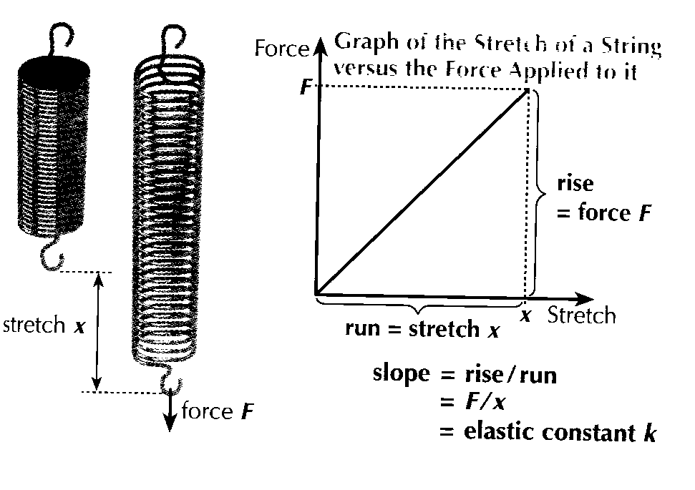
- Hooke’s Law states that: “For an elastic material, the stretch is proportional to the applied force.”

- The graph shows that the stretch, X, of the spring is proportional to the applied force, F, as the graph is a straight line through the origin. The spring must be an elastic material.
- The slope of the graph represents the elastic constant k sometimes referred to as its stiffness. The slope can be found by dividing the rise by the run:

Elastic constant = slope = rise/run
=force/stretch
k =F/x
The SI unit for the elastic constant (k) is newtons/metre (Nm⁻¹)

- This relationship is proportional when stiffness is constant.
- The area under the graph represents the elastic potential energy E_{p}, which is the energy stored in the stretched spring.

- This formula is used:

Elastic potential energy (E_{p})
= ½ * applied force * stretch
E_{p} = ½ Fx

The SI unit for energy is the joule (J)
- We can also write an expression involving the stiffness, k, which is constant for a sample that obeys Hooke’s Law:
E_{el} = ½ kx²

Area under the graph = ½ * breadth * height
Breadth = stretch, x
= ½ Fx
= Ep

- However, elastic objects that stretch under tension may not always return to their original position and in reality, results show that Hooke’s law is not closely followed.
- A point where the graph starts to deviate significantly from Hooke’s Law is called the Limit of Proportionality.
- With a rubber bungee cord, which doesn’t obey Hooke’s Law, the graph is curved and the area is thus estimated by counting the squares of graph paper under the curve. (see in handout)

Activity:
Pathfinder p52-3 no’s 2,3,5,7
Bungee Jumping from Advanced Physics pp39-43
Bungee egg drop

Conservation of Energy
- Energy is neither created nor destroyed, though it may change from one type ot another and it may be given by one body to another. The total energy remains constant.
- A freely-falling object loses potential energy Ep and gains kinetic energy, Ek. By the conservation of energy, we must have: loss in E_{p} = gain in E_{k}
mgh = ½ mv²
- Since energy is conserved, the total energy E= E_{p} + E_{k} remains constant.
- Conservation of energy assumes that the object is in free fall, where there is no opposing force to the object’s weight.
- However, a friction force will be present due to the resistance of the air which opposes the motion. This causes some of the mechanical energy to be dissipated as heat energy. In this case the gain in Ek will be smaller than the loss in Ep.
- When an object of mass, m, falls from a height, h, above the floor, the speed of the object just before it hits the ground can be calculated using the Law of Conservation of Energy.
mgh = ½ mv²
v = √ 2gh

Examples:
- Tahi (mass 75kg) dives off a diving board that is 2m above the surface of a swimming pool. Calculate Tahi’s speed on entering the water.
v = √ 2gh
= √ 2* 10*2
= 6.3ms⁻¹
- Clare starts from rest and skis down a slope which we take as frictionless. Find her speed when she has descended a vertical distance of 5m. Her mass, including skis etc.. is 70kg.
v = √ 2gh
= √ 2* 10*5
= 10ms⁻¹

- A steel ball-bearing of mass 0.1kg falls from a height of 2m onto the ground.
  - what is the loss of Ep when it reaches the ground? 0.1*10*2 = 2J
  - What will be its Ek as it reaches the ground? 2J (energy is conserved)
  - Find the speed of the ball-bearing when it reaches the ground.
v = √ 2gh
= √ 2* 10*2
= 6.3ms⁻¹

Bungee Egg Drop Challenge

BACKGROUND
Bungee jumping is a sport enjoyed by some daring individuals who hurl themselves from bridges, cranes, etc. with only an elastic cord to impede their otherwise inevitable impact with the ground. Bungee jumpers believe that the elastic cord will absorb the potential energy of their fall without breaking, and before they hit the ground. The design of such a thrill involves calculating the point at which the gravitational potential energy lost during the jumper's fall equals the elastic potential energy (similar to a spring) gained by the elastic cord. To ensure maximum thrill this point is designed to be as close to the ground as safely possible.

Your goal is to give the egg an exciting ride; therefore, during its flight, the egg should fall quickly (a long free-fall) and come as close to the ground as possible without, of course, damaging the egg. Note that there are two ways to damage the egg: hitting the ground and decelerating too rapidly (what will happen to a person if the cord they are attached to doesn’t stretch?).

CONTEST:
- Students construct a bungee cord by tying rubber bands together. The bungee cord is attached to a plastic bag containing a raw egg.
- Students will test their accuracy with a bungee egg contest to see which egg gets closest to the floor without breaking at a height to be decided by the teacher.
EQUIPMENT SUPPLIED (but you can ask for more): tape, paper clips, rubber bands, plastic ziplock bags, 3 raw eggs per group (2 for practice, 1 for the competition), meter sticks, tape measures
Consider how you will protect the egg whilst practicing as you will NOT be given any extras!!!
The Experimental Stage : Gather your data as follows:
- You will be given the height of the competition jump at a later stage. Thus, what you have to prepare is the number of rubber bands required for a jump at different heights that will deliver your egg towards the floor without breaking it.
- Make 3 jumps each with 3, 4, 5 (until you reach as many as you will need) rubber bands from at least 3 heights of at least 1m. The more heights you trial, the better your competition jump will go.
- Record how far the egg travels from the top of the meter stick to the point closest to the ground. Be very careful with your egg - protect it from hitting anything and make sure that it doesn't swing back and hit the meter stick.
- Accuracy is important, so the same person should drop the egg each time, and the same person should be watching the meter stick or tape measure each trial.
- Average each trial and graph your results to determine the optimum number of rubber bands for each height so that you will be confident of your bungee machine that will be built for the competition.

The Contest - Directions
You will be given the height of the competition bungee jump and now you need to:
- Build, but DO NOT TEST the bungee machine, using the appropriate number of rubber bands for the height from your trialling, then leave it alone in a safe place until we come back together as a class. I.e. DO NOT measure the length of the assembled bungee cord in any way, and DO NOT change or test your apparatus at all.
- When it is your group's turn, bring your bungee machine and your group's sheet up to the front of the room. Perform the jump. The team that comes closest to the ground without any egg damage wins.
Power and Work Done

Reintroduce Work with examples from p64 ESA L1 book

- Power is the rate at which work is done or the rate at which mechanical energy is transferred.
- Power has the following properties:
  - Power is proportional to the work done. The more work done, the more power is exerted.
  - Power is inversely proportional to the time taken. The less time taken, the more power is exerted.
- Power can be calculated: Power = work done(F*d) ÷ time taken
P = W/t
The SI unit is watt (W) which means a joule per second (Js⁻¹)
- For constant speed v = d÷ t so Power = F * v
To calculate power, the force and the velocity must be in the same direction.
- Eg: Superman can rescue 3 trapped miners in the time that Spiderman takes to rescue one. Superman is 3x as powerful as Spiderman
- Wonderwoman runs to the top of a hill in 5 minutes while Kylie, who has the same mass as Wonderwoman, takes 30 minutes to run up the hill. Wonderwoman is 6x as powerful as Kylie.
- A car travels at a constant velocity of 50kmh⁻¹ (14ms⁻¹). In order to overcome friction and wind resistance, the motor exerts a force of 800N. The power the motor is developing is:
Power = F * v = 800 * 14 = 11200W = 11.2kW

Pathfinder p52-3 6 , 8, 9
AS Physics eg from p36

Body Power – design and carry out experiment.

2003
SCIENCE
Level One

Achievement Standard 90186 (S1.1)
Carry out a practical investigation with direction
Credits: 4

Student Instructions Sheet
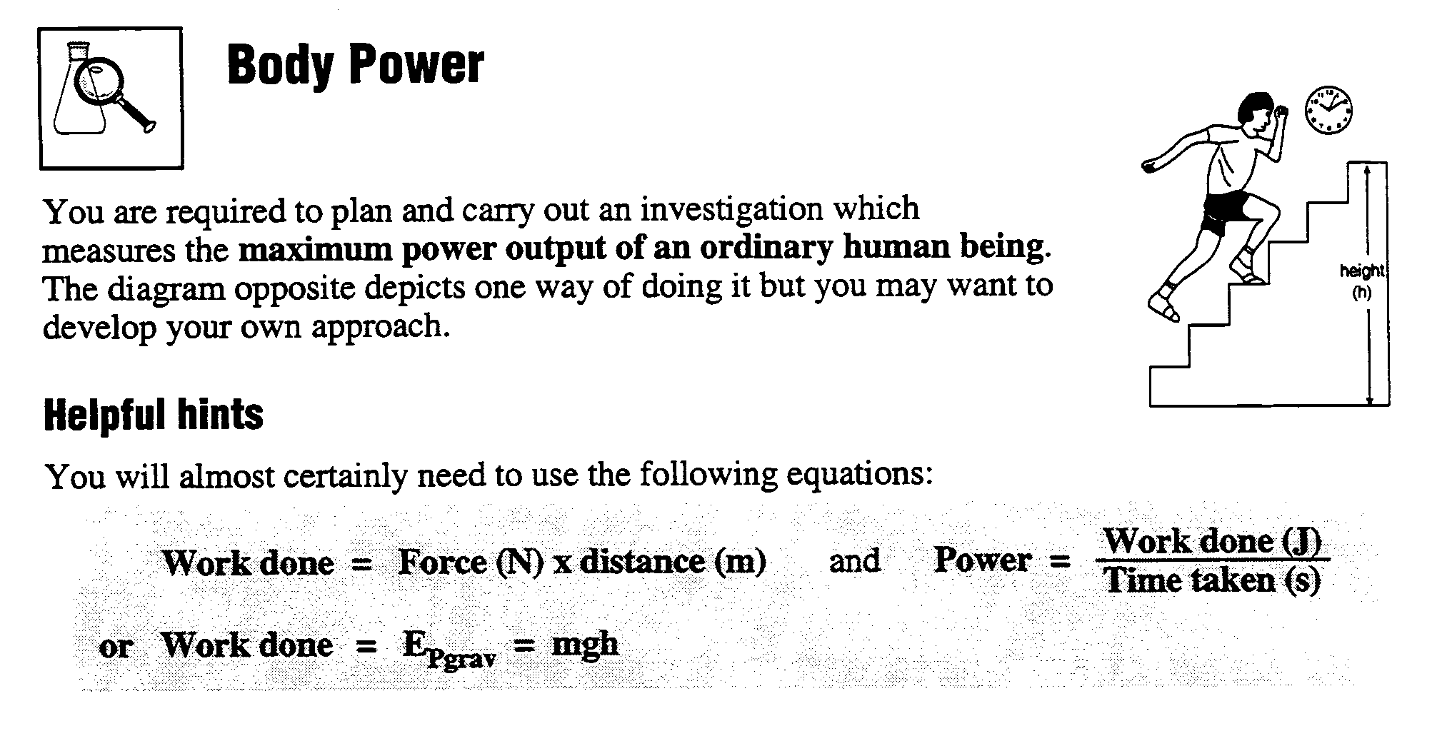

PART 1 Planning an investigation: (Individual Activity)

- Write a plan for a fair test measure the maximum power output of a human being

- Identify the key variables involved :
- The independent variable (the variable that is to be changed)
- The dependent variable (the variable that will be measured)
- Controlled variables (significant variables that will need to be kept the same to make your results more reliable)

- Describe a suitable range of values to be used for the independent variable and how these values will be changed. These may need to be established by trialling.

- Identify any other variables that might influence your investigation and describe how they will be controlled or measured to make your results more accurate.
- Describe how you will ensure that your results are reliable. This should include factors such as sources of error and sufficiency of data.
- Write a detailed step-by-step method that you will use. You may change your method as you carry it out as long as you describe any changes made to the method in your report.

PART 2 Collecting and recording results:

- Follow your method to collect data and record the results in a table or another systematic way.
- Remember to record any changes to your method and reasons for the changes as you go.
- Record any difficulties with equipment, measuring or the plan followed.

Each member of the group must record their own copy of the results..

PART 3 Processing, interpreting and presenting: (Individual Activity)

Your report will include:
- Your copy of the Investigation Plan Sheet.
- Detailed step-by-step method, including any changes made during your investigation
- The information and observations collected presented in a systematic way.
- Processing of the results. This may involve calculations and/or graphs as appropriate.
- Interpretation of your results to identify the pattern or trend they show.
- A conclusion giving your interpretation of the results linked to the purpose of the investigation.
- A discussion of science ideas that relate to the findings of the investigation or an evaluation of the investigation.
  - An evaluation could include any limitations of the investigation, the effect of other variables that you did not allow for, difficulties in the use of equipment, limitations of the findings, and where relevant, any suggested solutions to these.
  - A discussion will use science ideas to explain your results
Investigation Plan Sheet for Body Power Student Name:
1. Purpose of investigation (this may also be in the form of an aim, testable question, prediction or hypothesis)

2. Which variable will be changed? (This is the independent variable)

How will the independent variable be changed?

Give a suitable range of values for this variable:

3. Which variable do you think you will have to measure or observe in order to get some data or information from the investigation? (This is the dependent variable)

How will the dependent variable be measured or observed?

4. Other variables that need to be controlled to make your results more accurate
Variable | Describe how this variable will be controlled or measured
5. How will you ensure that your results are reliable?

6. Notes from your trials

Now use the information on this planning sheet to write a detailed step-by-step method on your own paper.

Assessment Schedule for Sci/1/1 90186: Body Power
Evidence | Achievement Judgement | Merit Judgement | Excellence Judgement
Report (planning sheet and method) | Plan identifies:  - purpose of the investigation  - the independent variable  - dependent variable | Plan is feasible i.e. method can be followed to obtain relevant data. The method lacks some detail and cannot be independently followed without further clarification | Plan is workable and can be independently followed without further clarification to obtain reliable data
Report (recorded and processed results) | - Data is relevant to the purpose  - Data is processed appropriately to enable a trend or pattern (or absence) to be identified  - Systematic data table that is able to be interpreted correctly  - Information recorded for at least one trial for each value of the key variable. | - Data is relevant to the purpose  - Data is processed appropriately to enable a trend or pattern (or absence) to be identified  - Systematic data table that is able to be interpreted correctly  - Information recorded for at least one trial for each value of the key variable. | - Data range or number of repeats will enable a reliable trend or pattern (or absence) to be identified  - Data processing allows a trend or pattern (or absence) to be interpreted  - At least 2 repeats of each key variable  - An average of each result is evident in a table or graph.  - Systematic data table with headings and units.
Report (conclusion, discussion or evaluation) | - Interpretation is based on the data obtained | - Conclusion links the findings of the investigation to the purpose | Either  - Evaluation provides justification for change (or no change) to method  OR  - Discussion uses science ideas to explain the trend or pattern (or absence) in results.
To determine the overall level of performance, all judgements within a column must be met.
For each judgement, evidence can be obtained from anywhere in the report.

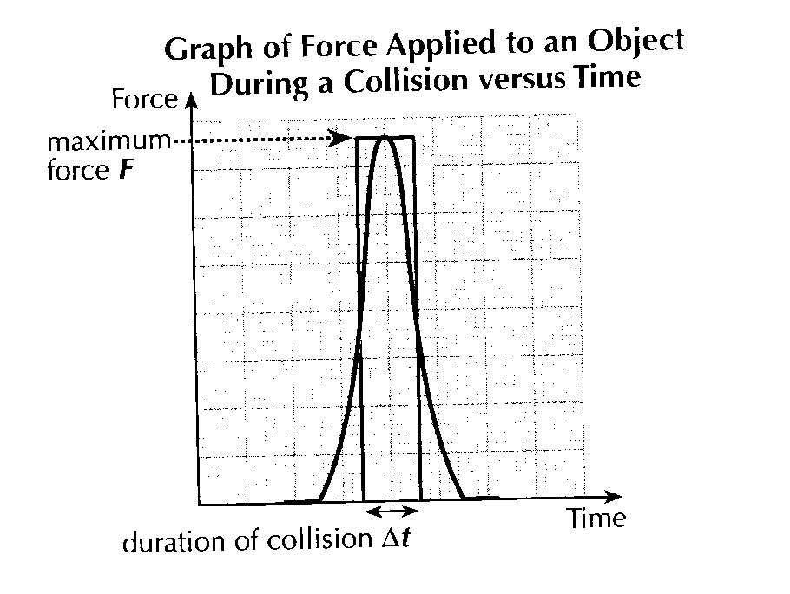
Momentum and Impulse
- The graph shows the size of the force on an object, which is suffering a collision caused by another object, plotted against the time. The force acts for only a brief time interval. (curved line)
- The collision can be simplified by assuming that during the collision, the maximum force, F on the object acts for a short duration Δt. (square line)

- Impulse I is the produce of the Force acting on an object during a collision and the duration of the collision. The units are newton seconds (Ns).
Impulse = F*Δt
I = F*Δt
- Momentum p is the product of the mass of an object and its velocity. The units are kilogram metres per second (kgms⁻¹)
Momentum = mass * velocity
p = m*v
- It can be shown that during a collision, the impulse acting on an object is equal to the change in momentum Δp of the object.
Impulse = change in momentum
I = Δp

Conservation of Momentum
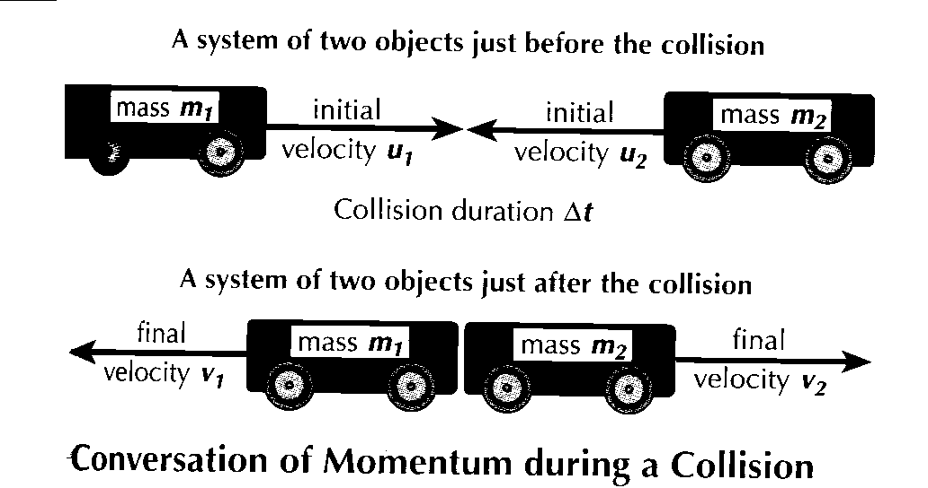
- A system is a set of interacting objects
- This diagram shows a system of 2 objects of masses m1 and m2 and initial velocities of u1 and u2, which are about to collide. After collision, the objects move away with final velocities, v1 and v2.
- The change in momentum Δp₁ for object 1 equals the final momentum p_{f} less the initial momentum p_{i}
p₁ = p_{f} - p_{i} = m₁v₁ – m₁u₁
- The change in momentum Δp₂ for object 2 equals the final momentum p_{f} less the initial momentum p_{i}
P₂ = p_{f} - p_{i} = m₂v₂ – m₂u₂
- The principle of conservation of momentum states that: “For an isolated system, the total momentum does not change during a collision”.
- An isolated system is one unaffected by outside influences.

Forces during a Collision
- Substituting I = F*Δt into the formula I = Δp ⇒ FΔt = Δp ⇒ F= Δp÷Δt
- The force acting on each of the objects during the collision is their Δp ÷ Δt
- The principle of conservation of momentum means that the total change in momentum must be zero.
- The Δp for object 1 plus the Δp for object 2 must equal zero.
Δp₁ + Δp₂ = 0 ⇒ Δp₁ = -Δp₂ ⇒ Δp₁÷Δt = Δp₂÷Δt ⇒ F₁ = -F₂
- The forces acting on the 2 objects for the duration of time of the collision are balanced.
MOMENTUM

INSTRUCTIONS:
- For both parts of this experiment draw up a table as shown below. (Of course leave plenty of room for your answers)
- Fill in both boxes on the left hand “Prediction” side BEFORE you do the experiment.
- Fill in both boxes on the right hand “Actual Outcome” side AFTER you have done the experiment.
Prediction | Actual Outcome
What will happen when the two trolleys are let go? (Be specific) | What happened?
Reason (Use the terms momentum, speed and mass) | Were you correct? (If you were not right think of a reason why)

Part 1:
- Two trolleys are pushed together. There is a spring between them that compresses as the trolleys are pushed closer together.
- Two blocks of wood are placed 50 cm behind each trolley.
- When the trolleys are let go the spring gives the same momentum to each trolley.
Spring
50 cm
50 cm

Part 2:

- The same trolleys are set up and pushed together again but this time one of the trolleys has a 500 g mass placed on it. (Remember the spring gives the same momentum to each trolley)
Spring
50 cm
50 cm
500 g mass

Part 3:
- Place three balls at the bottom of a track and roll two balls together down to hit them.

QUESTIONS:
The diagrams show trolleys connected by a spring. For each situation write down where the second block of wood should be placed (distance and position) so that the trolleys hit both blocks at the same time when they bounce apart.

(a)
30 cm
Spring
30 cm

(b)

(c)
20 cm

(d)

25 cm

 | Conduction | Convection | Radiation
Types of Particles Involved | Solids | Liquids and Gases | Solids, liquids, gases
Particle movement  (in words) | When a region is heated, its particles have more kinetic energy and they vibrate. The vibrations cause the atoms to pass the heat energy on and so on moving from warmer to cooler areas. Only works in solids because the particles are close enough for vibrations to be passed on | When particles are heated they move further apart becoming less dense and less dense (hotter) particles rise. Cooler particles are more dense and they sink. In this manner, a circular convection current is set up | The sun radiates energy as electromagnetic waves. They warm up anything that absorbs them and the waves are known as radiation. They do not need a medium to travel in ie they move through a vacuum but can be absorbed (or reflected) by all types of particles
Particle movement  ( diagram) | 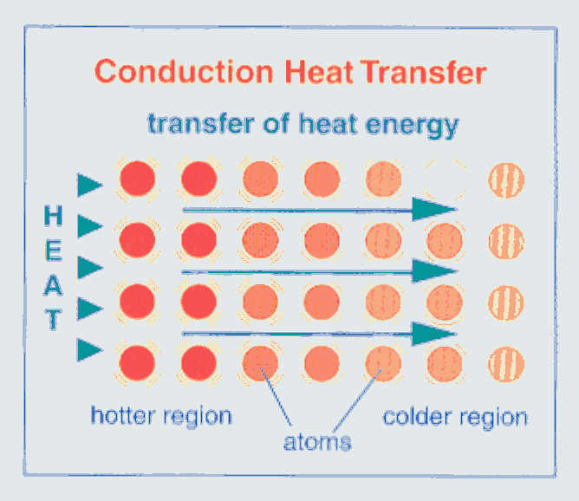 | 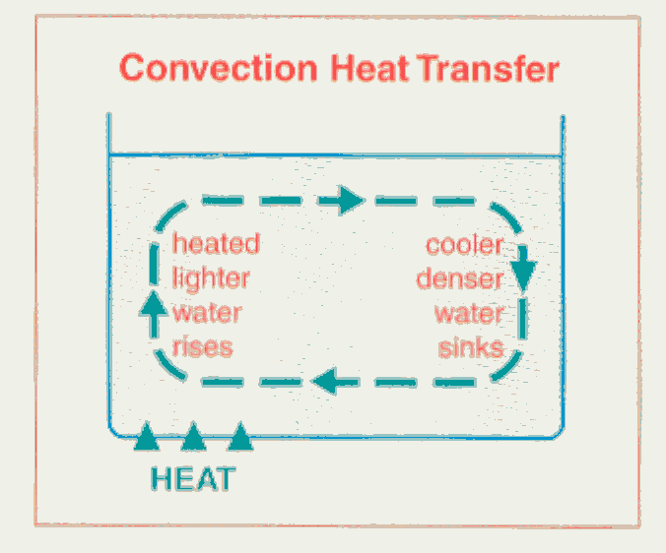 | 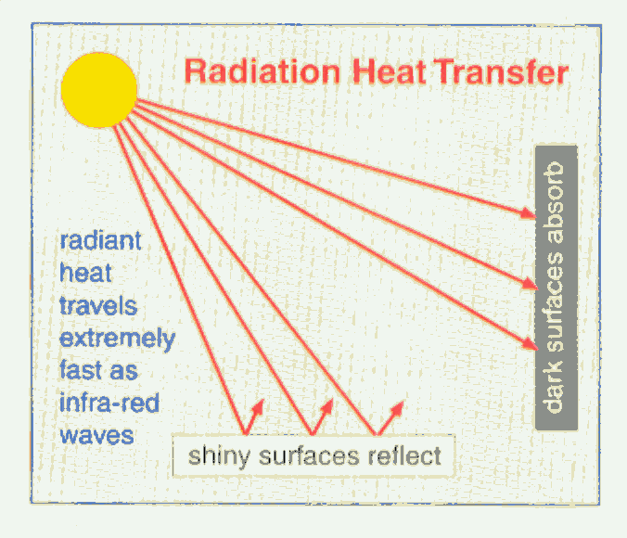
Good examples of: | Metals especially copper and silver |  | Black absorbs and emits well
Poor examples of: | Wood, air, fibreglass, plastic, cork, glass  INSULATORS |  | White is a poor absorber and poor emitter  Silver absorbs very little, reflects nearly all that falls on them

www.learner.org/exhibits/parkphysics/index.html

www.funderstanding.com/k12/coaster/ but read the notes first

